Install VirtualBox, Ubuntu 22 VM: <https://www.youtube.com/watch?v=hYaCCpvjsEY>

Terminal not working on VM: Settings, Language & Region, Set Language as English (UK)

Confer sudo rights in VM: In terminal write „su -” (password of VM), „visudo”,

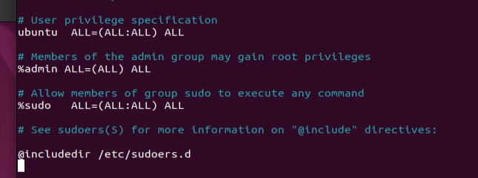

add the name of your user (ubuntu in my case).

Copy/Paste not working on VM: <https://superuser.com/questions/1318231/why-doesnt-clipboard-sharing-work-with-ubuntu-18-04-lts-inside-virtualbox-5-1-2>